Cache Framework Developer’s Guide

An Open Source Asset for use with TIBCO® Data Virtualization

|  |  |
| --- | --- |
| **Project Name** | AS Assets Cache Management |
| **Document Location** | This document is only valid on the day it was printed. The source of the document will be found in the ASAssets_CacheManagement folder (https://github.com/TIBCOSoftware) |
| **Purpose** | Developer’s Guide |

Revision History

|  |  |  |  |
| --- | --- | --- | --- |
| **Version** | **Date** | **Author** | **Comments** |
| 1.0 | 04/12/2017 | Mike Tinius | Initial revision |
| 1.1 | 12/06/2017 | Mike Tinius | Transitioned to Tibco for release 2017Q4 |

Related Documents

|  |  |
| --- | --- |
| **Name** | **Version** |
| How To Use Utilities.pdf | 2017Q4 |

Supported Versions

|  |  |
| --- | --- |
| **Name** | **Version** |
| TIBCO® Data Virtualization | 7.0 or later |
| AS Assets Utilities open source | 2017Q4 or later |

Table of Contents

1 Introduction 4

Purpose 4

Audience 4

References 4

2 Github Repository Structure 5

Recommended Development Tools 5

How Can I Download a Copy of the Cache Management GitHub Repository? 5

Repository Folder Structure 5

DocumentationSource 5

DVSource 5

DVSource/cis_objects 5

DVSource/scripts 5

JavaSource 5

JavaSource/lib 6

Release 6

Release/archive 6

3 Configure the Eclipse Development Environment 7

Checking Out the Cache Framework DV Source Code 7

Configure Eclipse Variables 7

Checking Out the Cache Management Framework Project 9

Clone the Cache Management Git repository to your local machine 9

Create a General project from the Git repository 12

Create a Java project from the Git repository JavaSource folder 15

1. Introduction

## Purpose

The purpose of this document is to provide guidance on how develop the AS Assets Cache Management Framework.

## Audience

This document is intended to provide guidance for the following users:

* Developers

## References

Product references are shown below. Any references to CIS or DV refer to the current TIBCO® Data Virtualization.

* TIBCO® Data Virtualization was formerly known as
  + Cisco Data Virtualization (DV)
  + Composite Information Server (CIS)

1. Github Repository Structure

## Recommended Development Tools

CIS itself can (and should) be used for developing the SQL Script procedures. Any robust Java IDE can be used to develop the CJPs, however up to this point, the CJP's have been developed using Eclipse. The CJP artifacts in the open source repository (GitHub) are therefore geared towards an Eclipse project.

Git is used as the version control system for the ASAssets open source project. For those new to Git, a visit to <https://help.github.com/articles/set-up-git> will provide an overview of Git and instructions on downloading and setting up the basic Git tools.

## How Can I Download a Copy of the Cache Management GitHub Repository?

The GitHub master repository is located at <https://github.com/TIBCOSoftware/ASAssets_CacheManagement>.

## Repository Folder Structure

The folder structure of the GitHub repository contains CIS source, custom Java source, documentation source, and distribution resources.

### DocumentationSource

This folder contains the source versions of the user's guide and developer's guide (this document) in Microsoft Word format. When a release version of a document is ready for distribution, it should be saved in PDF format and placed in the Release folder.

### DVSource

This folder contains the source code for the DV resources.

### DVSource/cis_objects

This folder contains the exported CIS resources in the version control export format. Instead of a single .CAR file, the resources are exported in a folder tree structure that matches the container structure in CIS. A .CMF file named for the resource with a resource type suffix contains the resource's source code, model, ownership information, annotation, permissions, etc. A container will have a corresponding .CMF file contained inside it.

### DVSource/scripts

This folder will contain (still in development) a number of Windows batch files and Linux shell scripts that can be used to import the resources in the cis_objects folder into a CIS instance and export resources from a CIS instance into the cis_objects folder structure.

### JavaSource

This folder contains the source code for the DV resources. It contains an Eclipse project that can be used to build individual CJP data source jars or all of them in one build. Each CJP collection has a child folder here.

### JavaSource/lib

This folder contains library jar files used to build the CJP jars. Open source libraries have corresponding LICENSE.txt files. CIS libraries are named with a "cs" prefix.

### Release

This folder contains the current release of the project and corresponding documentation.

### Release/archive

This folder contains past releases of the project and corresponding documentation.

1. Configure the Eclipse Development Environment

## Checking Out the Cache Framework DV Source Code

TBD. For now, the best way to make sure a new or updated SQL Script gets into the next release is to send the script (plus documentation and examples!) in a CAR file to Mike Tinius.

## Configure Eclipse Variables

There are two variables that need to be created. One is for Eclipse and one is for Ant.

Create DV_HOME for Eclipse.

In Eclipse, select Window > Preferences > Java > Build Path > Classpath Variables > New

Enter Name: DV_HOME

Path: Browse to your data virtualization home folder

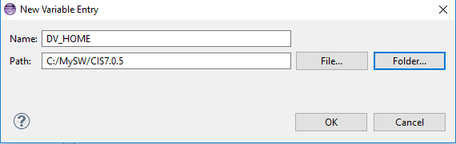

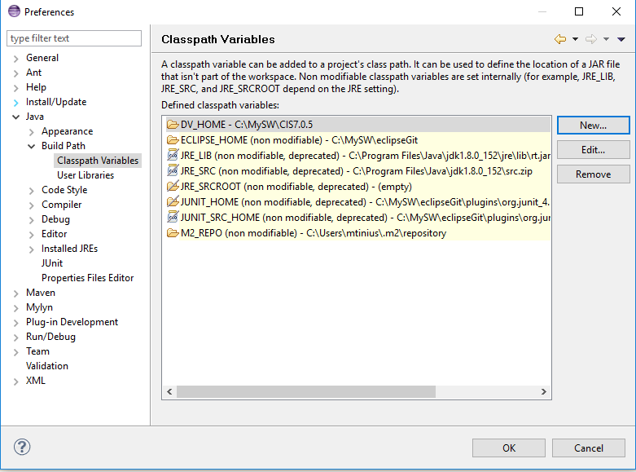

Create DV_HOME for Ant.

In Eclipse, select Window > Preferences > Ant > Runtime > Properties > Add Property

Enter Name: DV_HOME

Path: Locate your data virtualization home folder and type it or copy and paste it.

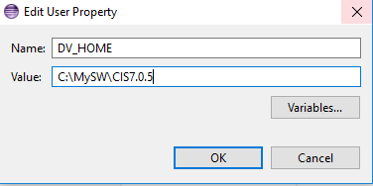

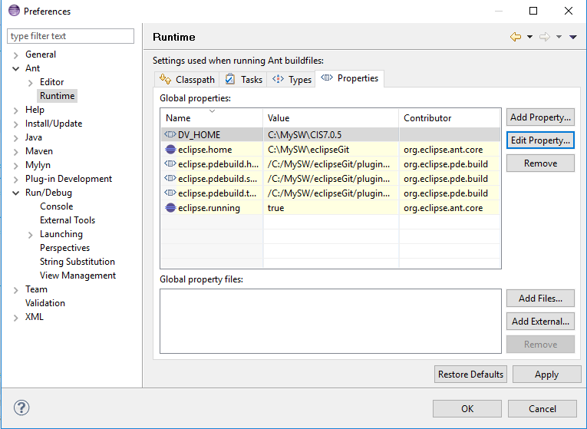

## Checking Out the Cache Management Framework Project

CJPs for the AS Assets are currently developed in Eclipse. These instructions are based on the Luna distribution of Eclipse (if not using this release then the following steps may need to be modified. For instance, Luna includes the Git client, whereas earlier releases of Eclipse do not.) If installing Eclipse for the first time, the "Eclipse Standard" (or "Eclipse IDE for Java Developers", if space is tight) should be used.

### Clone the Cache Management Git repository to your local machine

For the next steps, start Eclipse and make sure to apply any updates (Help -> Check for Updates).

1. Open the Git perspective using the "Open Perspective" panel in the upper right of the Eclipse screen:

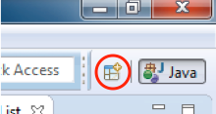

1. Choose the Git perspective:

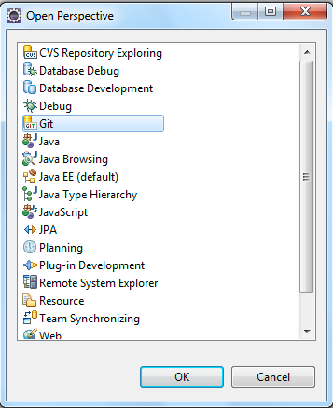

1. In the "Git Repositories" panel, click the "Clone a Git repository" link. Alternatively, go to the "File" menu and select "New"->"Other…" Choose "Git"->"Git Repository" from the resulting dialog.
2. In the resulting dialog, paste the Git repository URL ***https://github.com/TIBCOSoftware/ASAssets_CacheManagement.git*** into the "URI" field. The "Host" and "Repository Path" fields should auto-populate. Enter your Git user name and password and click "Next >".

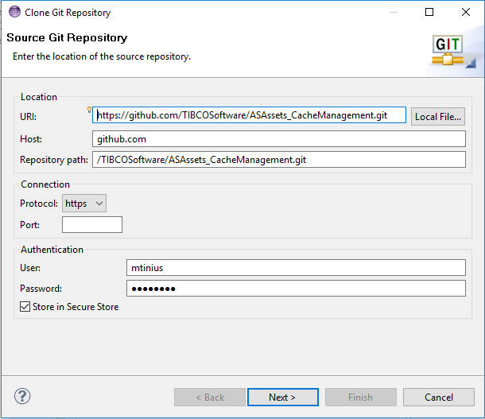

1. The "Branch Selection" screen should show one branch called "master". This should already be selected so click "Next >".

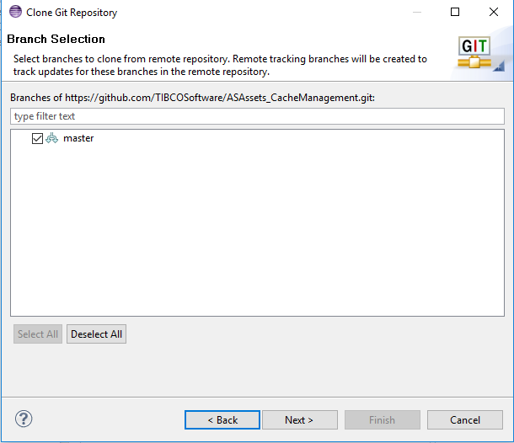

1. Choose the location where the downloaded source code should be stored. Click "Finish".

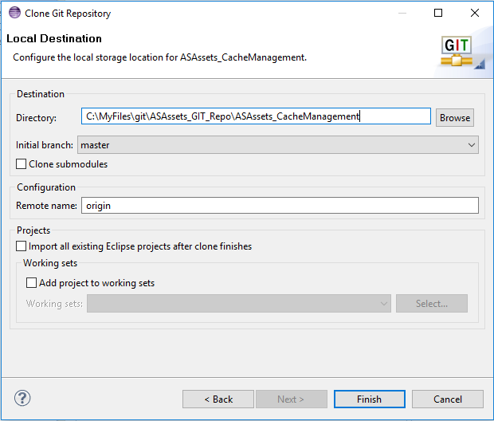

1. A progress dialog will appear indicating how far along the clone process is. Once done, the ASAssets_CacheManagement clone should then appear in your Git Repositories list.

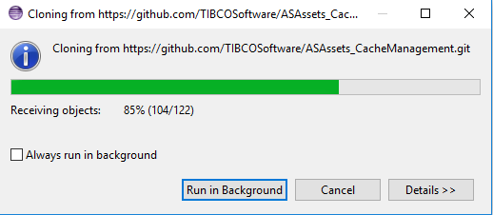

1. You may get an error stating that your secure store password has not been set. This can be safely ignored but it's probably a good idea to go into the Eclipse preferences and set a password for your secure storage.

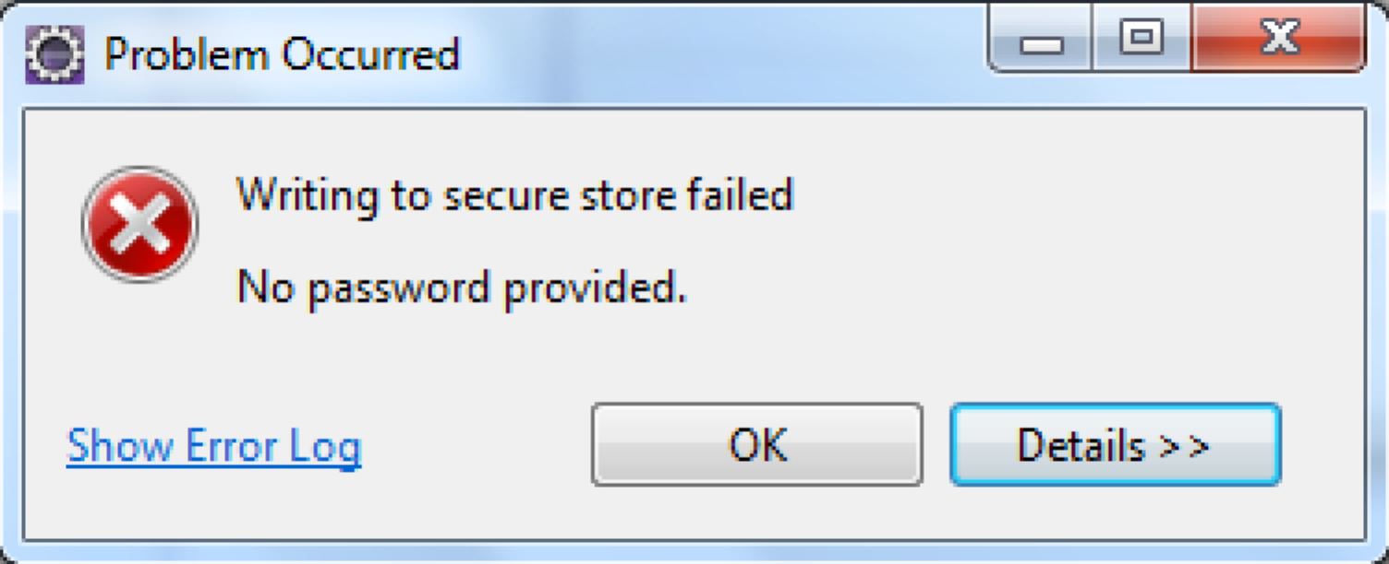

### Create a General project from the Git repository

1. Open the Java perspective clicking the "Java" perspective button in the upper right of the Eclipse screen.
2. Right-click in the "Package Explorer" panel on the left side of Eclipse. Select "Import …"
3. Drill into "Git" and select "Projects from Git". Click "Next >".

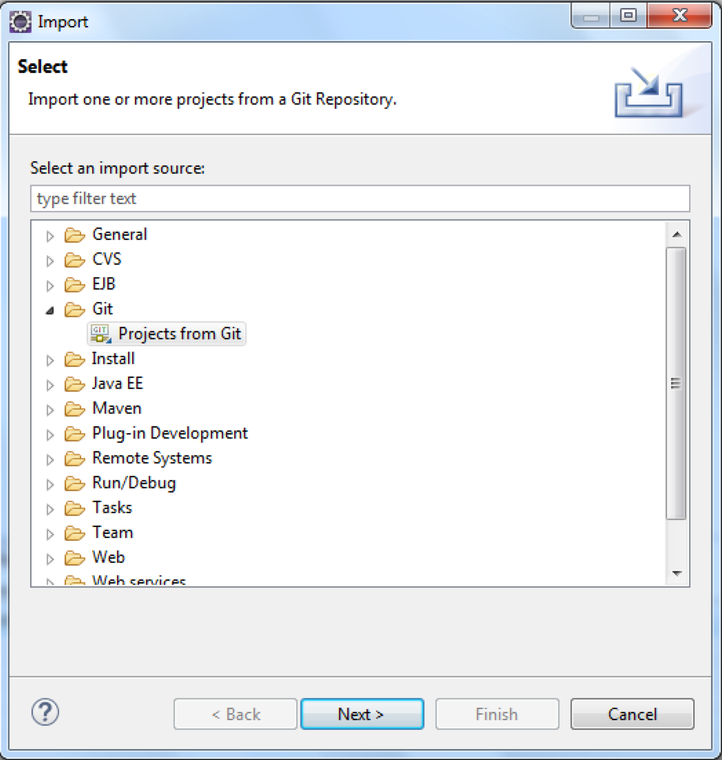

1. In the next panel choose "Existing local repository". Click "Next >".

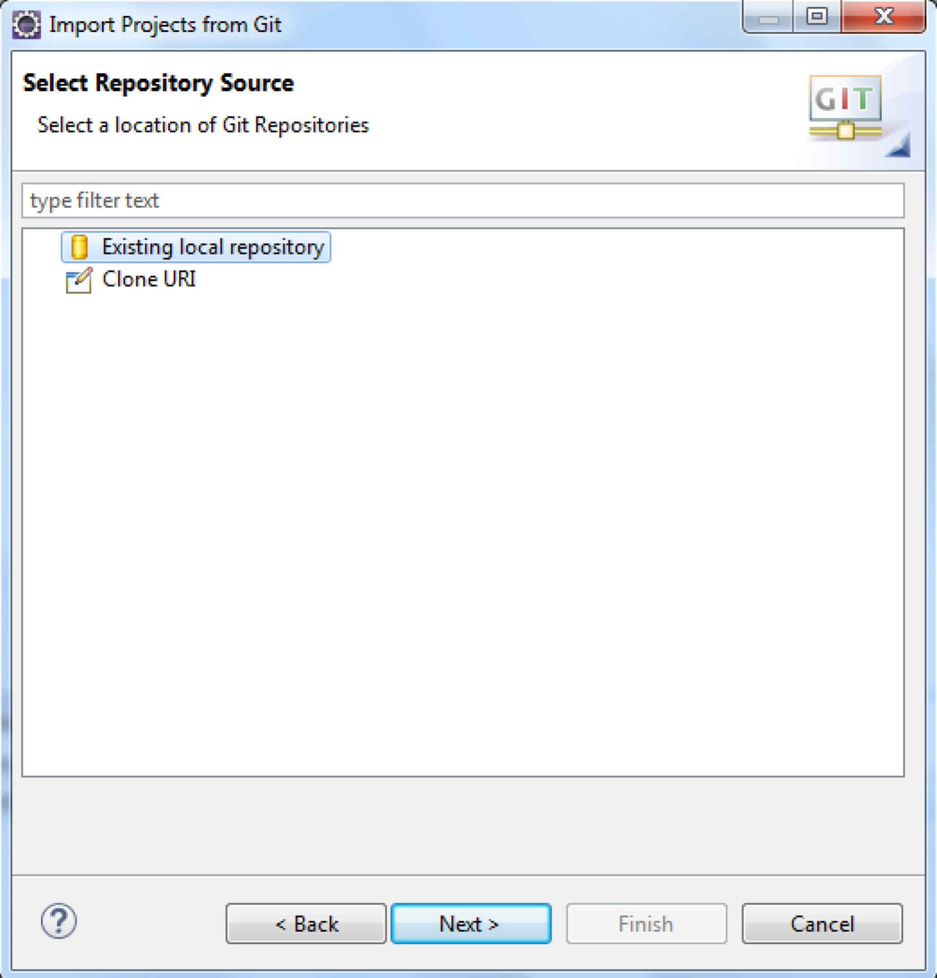

1. Choose the "ASAssets_CacheManagement" repository. Click "Next >".

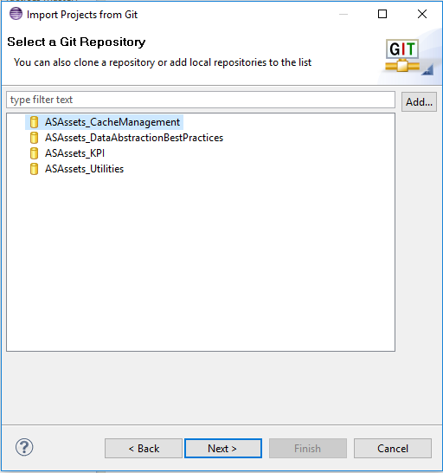

1. Select "**Import as general project**" as the root folder to import. Click "Next >".

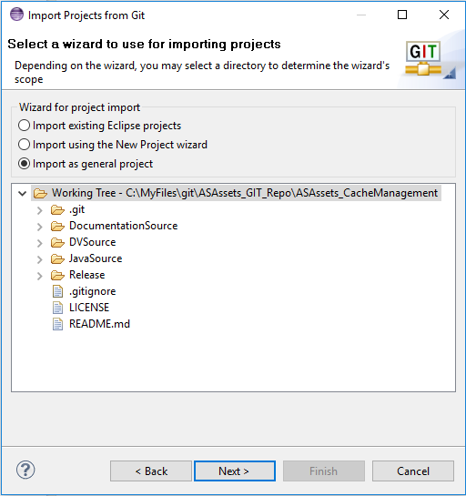

1. Select only the “ASAssets_CacheManagement” project and click "Finish".

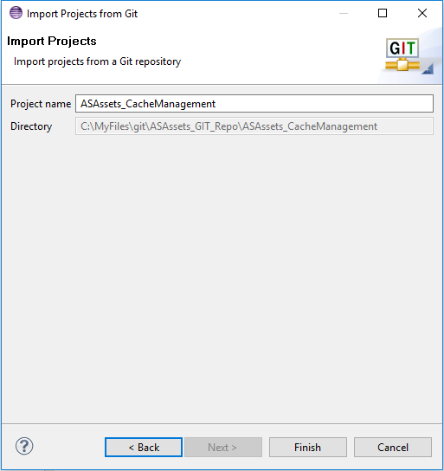

1. The imported project:

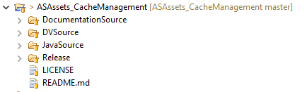

### Create a Java project from the Git repository JavaSource folder

1. There are no java projects associated with this project at this time.